# WRP Migration Procedure

1. Determine if the site is a ‘**DOD’** or a ‘**non DOD’** site
2. Backup IQCare production Database and Include date in backup name. See attached guide on how to Backup
3. Restore backup in (2) as **Migration_Test** Database. See attached guide on how to Restore a backup
4. If it’s a DOD site open the **WRP – DOD** folder else open the **WRP – non DOD** folder.
5. Right click on the **batch.bat** file and specify run as administrator.
6. Provide the details requested.

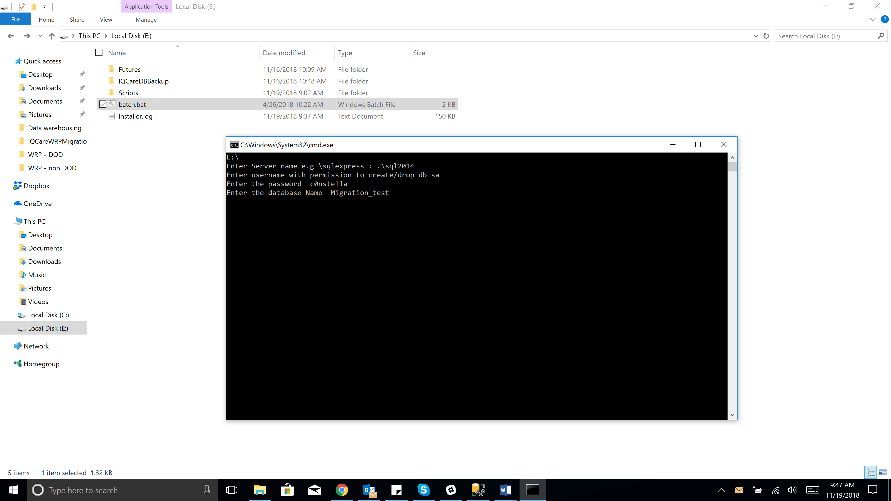

Note: Ensure you specify the database as **Migration_Test.**

1. Let the site know that the system will be unavailable. Ask users to log off and to stop data entry. Run the data verification procedure. See attached guide.
2. Once completed:
   1. Point IQTools to **Migration_Test** Database

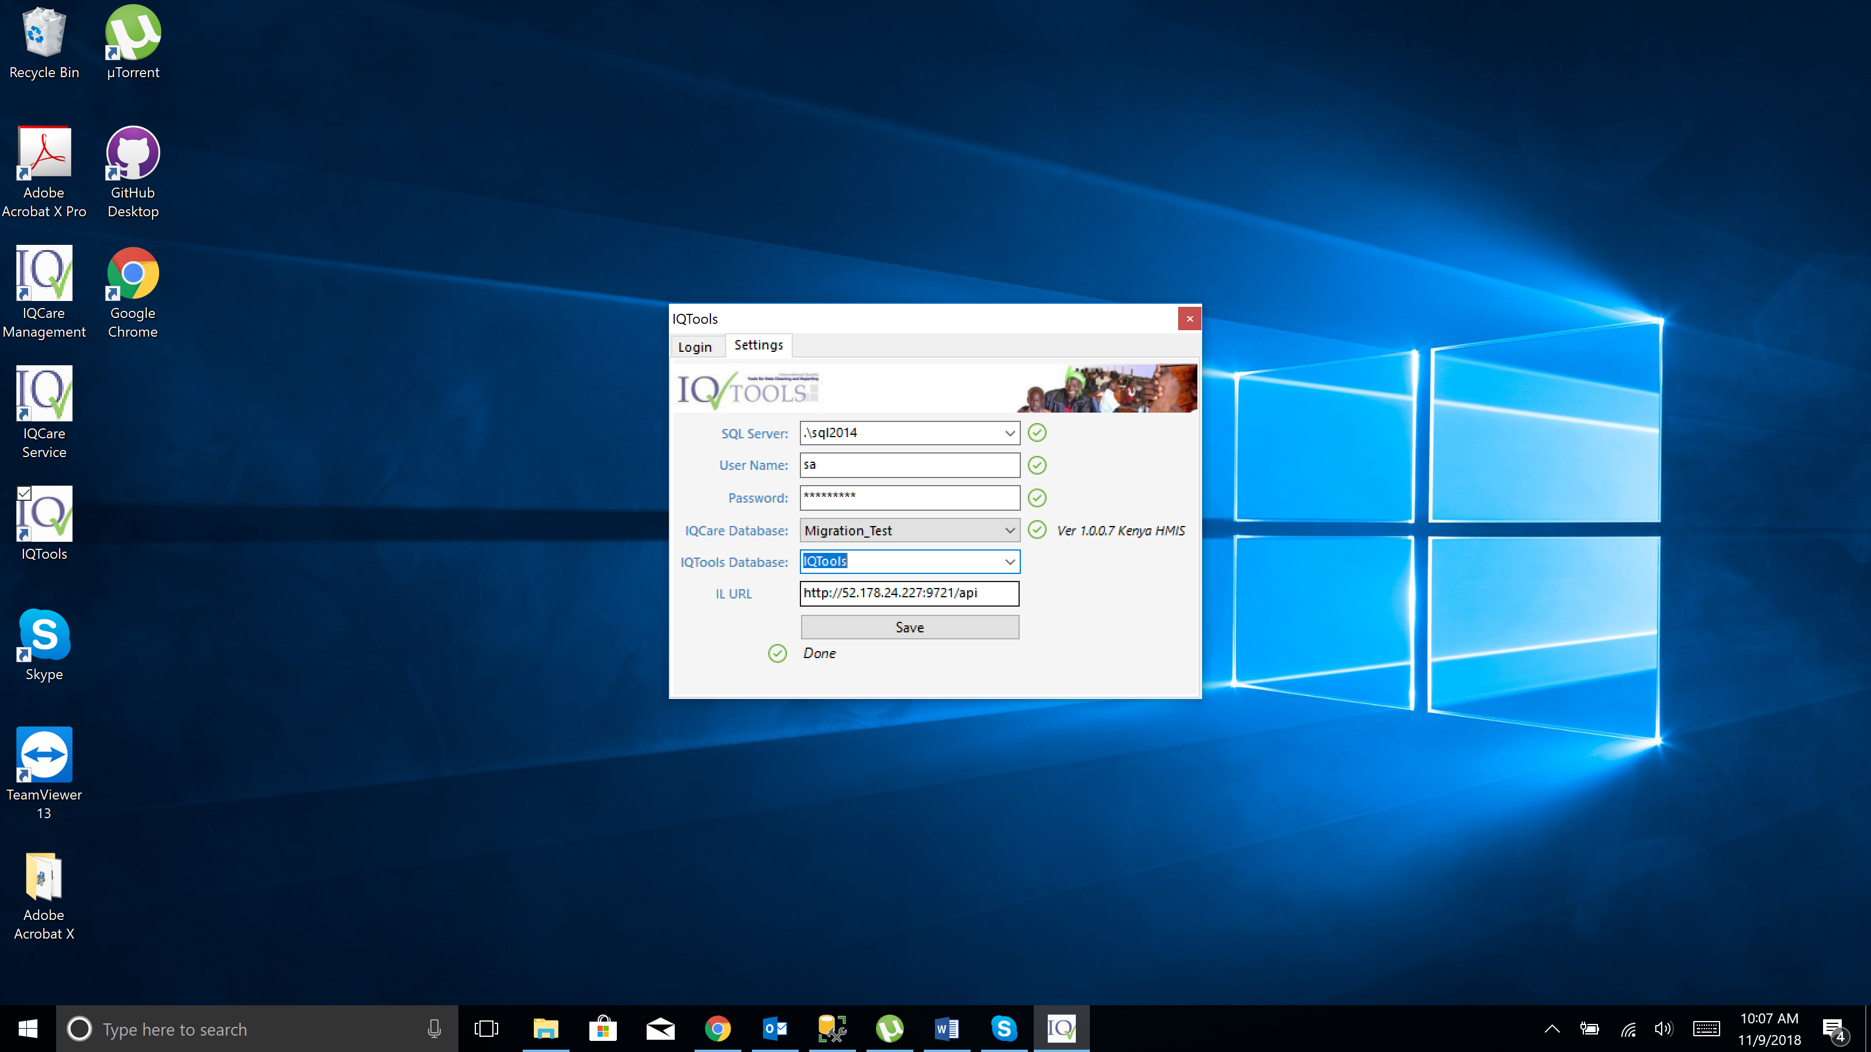

* 1. Click save.
  2. Log into IQTools and run refresh IQTools
  3. Run the reports.
  4. Validate the report numbers.

1. If reports are correct:
   1. Plan Site migration window
      1. Let the site know of planned Migration Date & Time
      2. Ask users to log off for migration period
      3. Stop IQCare Service

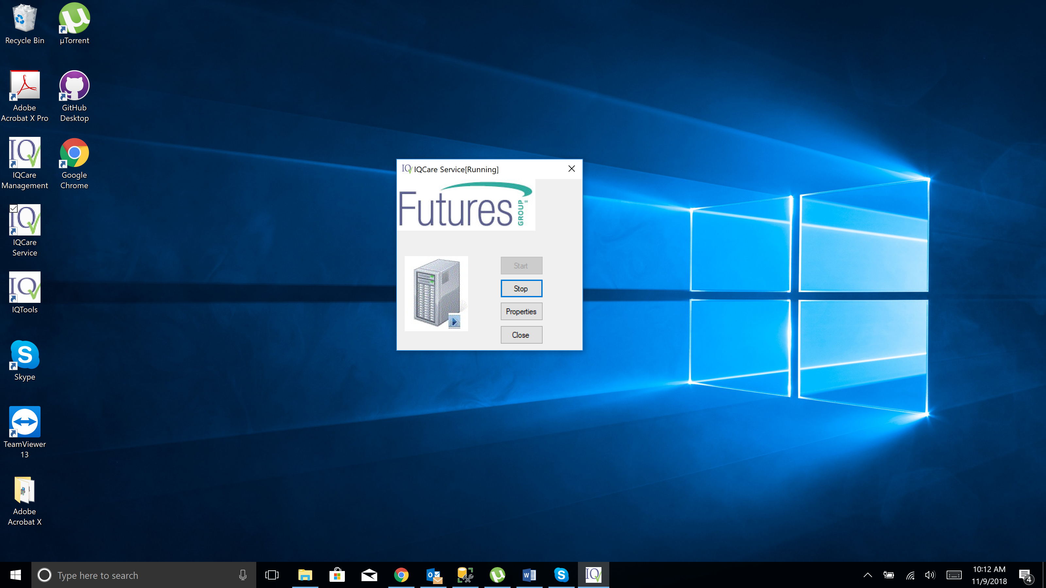

* + 1. Backup IQCare production database and include date in backup name
  1. Repeat process steps 4-8 on the IQCare Site production database
  2. Start IQCare Service
  3. Change IQTools connection string to point to IQCare Production database
  4. Notify site staff to continue working